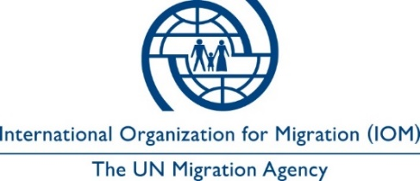

Invitation to Bid
Annual maintenance services for all A/C units in 9 south sites

ITB No.: 4200080987
Date: 14-07-2021

The International Organization for Migration (IOM) is an intergovernmental organization established in 1951 and is committed to the principle that humane and orderly migration benefits both migrants and society.

IOM invites interested eligible Suppliers to submit Quotations for the Annual maintenance services for all A/C units in 9 south sites.

The evaluation and award of contract will be conducted in total. IOM reserves the right to select the overall most favorable solution in case the difference in points between bids is not substantial.
Eligible bidders may request the complete set of Bidding Document and its Annexes at the following e-mail address iomgrprocurement@iom.int.

Quotations shall be valid for a period of thirty (30) calendar days after the submission deadline and shall be sent to the email iomathenstenders@iom.int , on or before 20th July 2021 at 17:00 hrs local time. No late proposal shall be accepted.

Bidding procedure will be conducted based on the rules of the International Organization for Migration.

IOM reserves the right to accept or reject any Quotation, and to cancel the procurement process and reject all Quotations, at any time prior to award of contract, without thereby incurring any liability to the affected Supplier/s or any obligation to inform the affected Supplier/s of the ground for IOM’s action.

IOM Greece
Megalou Alexandrou 7, 16452 Argyroupoli
Athens, Greece

